Week 01: Installs

Contents: Screenshots of installed softwares required for

the course

Abhilash Hemaraj

hemaraj.a@northeastern.edu

For INFO 7290; Data Warehousing and Business Intelligence

* 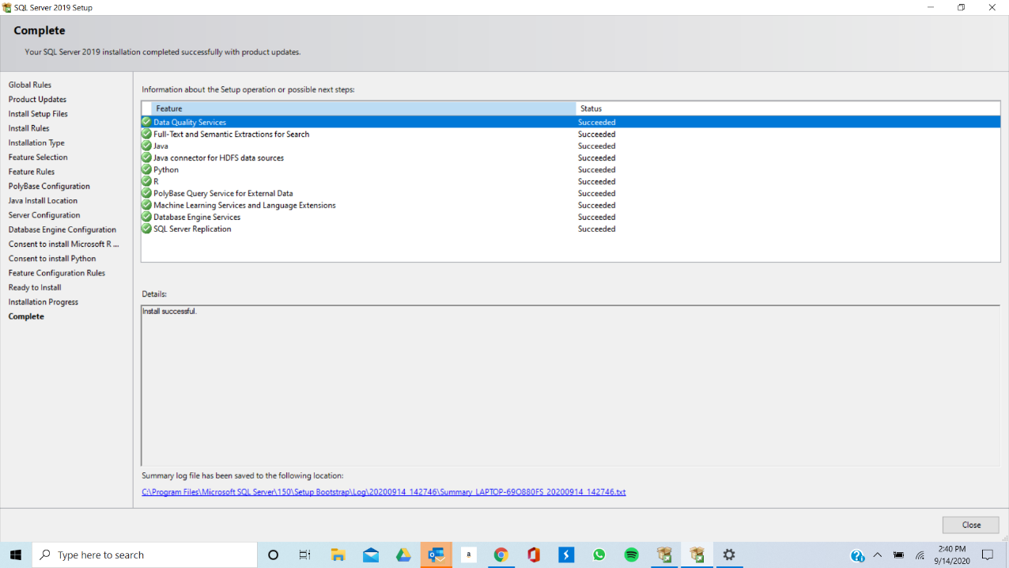**SQL Server Installation**
* **Adventure Works (Warehouse and Regular)**

* **Sql Server Data Tools for Visual Studio**

* **ER Studio**

